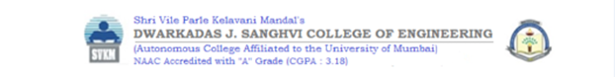

**Experiment 1**

**Date of Performance :**  **Date of Submission:**

**SAP Id: 60004190057** **Name : Junaid Altaf Girkar**

**Div:** **A** **Batch : A4**

**Aim of Experiment**

Design and Implement Encryption and Decryption Algorithm for

* Caesar cipher cryptographic algorithm by considering letter [A..Z] and digits [0..9]. Create two functions Encrypt() and Decrypt(). Apply Brute Force Attack to reveal secret. Create Function BruteForce(). Demonstrate the use of these functions on any paragraph.
* Affine Cipher. Your Program Must Input Image in Gray Scale. Choose keys according to Gray Scale Intensity level. Create two functions Encrypt() and Decrypt(). Make sure to have Multiplicative Inverse Exists for one of the Key in selected Key pair of Affine Cipher. (CO1)

**Theory / Algorithm / Conceptual Description**

**CAESAR CIPHER**

The Caesar Cipher technique is one of the earliest and simplest method of encryption technique. It’s simply a type of substitution cipher, i.e., each letter of a given text is replaced by a letter some fixed number of positions down the alphabet. For example with a shift of 1, A would be replaced by B, B would become C, and so on.

Thus to cipher a given text we need an integer value, known as shift which indicates the number of position each letter of the text has been moved down.

The encryption can be represented using modular arithmetic by first transforming the letters into numbers, according to the scheme, A = 0, B = 1,…, Z = 25. Encryption of a letter by a shift n can be described mathematically as.

| E_n(x)=(x+n)mod\ 26 |
| --- |

(Encryption Phase with shift n)

| D_n(x)=(x-n)mod\ 26 |
| --- |

(Decryption Phase with shift n)

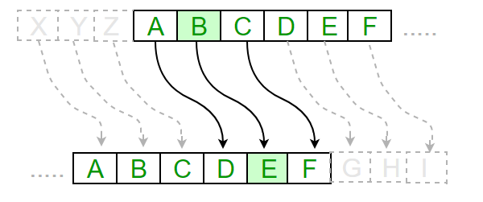

**HILL CIPHER**

Hill cipher is a polygraphic substitution cipher based on linear algebra.Each letter is represented by a number modulo 26. Often the simple scheme A = 0, B = 1, …, Z = 25 is used, but this is not an essential feature of the cipher. To encrypt a message, each block of n letters (considered as an n-component vector) is multiplied by an invertible n × n matrix, against modulus 26. To decrypt the message, each block is multiplied by the inverse of the matrix used for encryption.

The matrix used for encryption is the cipher key, and it should be chosen randomly from the set of invertible n × n matrices

**Encryption**

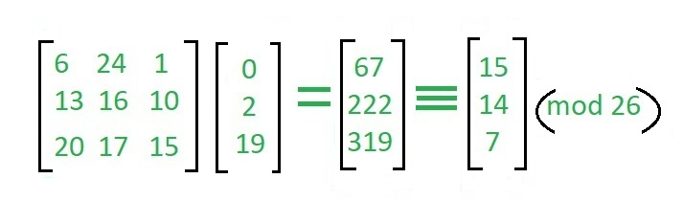

**Decryption**

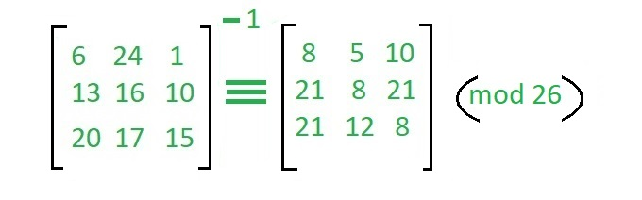

**Program**

A)

| # Encryption and decryption of a message using a caesar cipher  def encrypt(message, key):   encrypted_message = ""  for letter in message:  if letter.isupper():  encrypted_message += chr((ord(letter) + key - 64) % 26 + 65)   else:  encrypted_message += chr((ord(letter) + key - 96) % 26 + 97)   return encrypted_message  plain_text = "UkraineIsACountryInEasternEurope" key = 5  print("PLain text: ", plain_text) print("Key: ", key) print("Cipher Text : " + encrypt(plain_text, key))  def decrypt(cipher_text, key):  decrypted_message = ""  for letter in cipher_text:  if letter.isupper():  decrypted_message += chr((ord(letter) + key - 65) % 26 + 65)   else:  decrypted_message += chr((ord(letter) + key - 97) % 26 + 97)   return decrypted_message  def brute_force_decrypt(cipher_text):  for i in range(26):  print("Key: ", abs(25 - i))  print("Decrypted Text: " + decrypt(cipher_text, i))  brute_force_decrypt(encrypt(plain_text, key)) |
| --- |

**Output**

| PLain text: UkraineIsACountryInEasternEurope  Key: 5  Cipher Text : AqxgotkOyGIuatzxeOtKgyzkxtKaxuvk  Key: 25  Decrypted Text: AqxgotkOyGIuatzxeOtKgyzkxtKaxuvk  Key: 24  Decrypted Text: BryhpulPzHJvbuayfPuLhzalyuLbyvwl  Key: 23  Decrypted Text: CsziqvmQaIKwcvbzgQvMiabmzvMczwxm  Key: 22  Decrypted Text: DtajrwnRbJLxdwcahRwNjbcnawNdaxyn  Key: 21  Decrypted Text: EubksxoScKMyexdbiSxOkcdobxOebyzo  Key: 20  Decrypted Text: FvcltypTdLNzfyecjTyPldepcyPfczap  Key: 19  Decrypted Text: GwdmuzqUeMOagzfdkUzQmefqdzQgdabq  Key: 18  Decrypted Text: HxenvarVfNPbhagelVaRnfgreaRhebcr  Key: 17  Decrypted Text: IyfowbsWgOQcibhfmWbSoghsfbSifcds  Key: 16  Decrypted Text: JzgpxctXhPRdjcignXcTphitgcTjgdet  Key: 15  Decrypted Text: KahqyduYiQSekdjhoYdUqijuhdUkhefu  Key: 14  Decrypted Text: LbirzevZjRTflekipZeVrjkvieVlifgv  Key: 13  Decrypted Text: McjsafwAkSUgmfljqAfWsklwjfWmjghw  Key: 12  Decrypted Text: NdktbgxBlTVhngmkrBgXtlmxkgXnkhix  Key: 11  Decrypted Text: OeluchyCmUWiohnlsChYumnylhYolijy  Key: 10  Decrypted Text: PfmvdizDnVXjpiomtDiZvnozmiZpmjkz  Key: 9  Decrypted Text: QgnwejaEoWYkqjpnuEjAwopanjAqnkla  Key: 8  Decrypted Text: RhoxfkbFpXZlrkqovFkBxpqbokBrolmb  Key: 7  Decrypted Text: SipyglcGqYAmslrpwGlCyqrcplCspmnc  Key: 6  Decrypted Text: TjqzhmdHrZBntmsqxHmDzrsdqmDtqnod  Key: 5  Decrypted Text: UkraineIsACountryInEasternEurope  Key: 4  Decrypted Text: VlsbjofJtBDpvouszJoFbtufsoFvspqf  Key: 3  Decrypted Text: WmtckpgKuCEqwpvtaKpGcuvgtpGwtqrg  Key: 2  Decrypted Text: XnudlqhLvDFrxqwubLqHdvwhuqHxursh  Key: 1  Decrypted Text: YovemriMwEGsyrxvcMrIewxivrIyvsti  Key: 0  Decrypted Text: ZpwfnsjNxFHtzsywdNsJfxyjwsJzwtuj |
| --- |

**Program**

B)

| from scipy import misc import imageio import numpy as np import matplotlib.pyplot as plt import os.path import pickle from numpy.linalg import inv, det import sys import scipy.misc  # IMAGE SECTION  def read_image(image_path):  """ Read an image and return a one hot vector of the image"""  img = imageio.imread(image_path)  reshape_value = 1   for i in img.shape:  reshape_value *= i   return img.reshape((1, reshape_value)), img.shape   def show_image(image):  """ Show a single image"""  plt.imshow(image)  plt.show()   def show_images(a, b):  """ Show two images side by side"""  plot_image = np.concatenate((a, b), axis=1)  plt.imshow(plot_image)  plt.show()  # HILL CLIMB SECTION  class HillClimb:  def __init__(self, data, file_name, key_path=None):   self.data = data   # Computet the chunk  self.chunk = self.computer_chunk()   if key_path:  # Load the key if it exist in the current dir  self._key = pickle.load(open( key_path, "rb" ))  print('Usigng the args -k ' + key_path)  else:  file_name = file_name + '.key'   if os.path.isfile(file_name):  # Load the key if it exist in the current dir  self._key = pickle.load(open( file_name, "rb" ))  print('Usigng the ' + file_name)  else:  # Generate a random key  self._key = np.random.random_integers(0, 100, (self.chunk, self.chunk))    # If determinat is equal to zero regenrate another key  if det(self._key) == 0:  self._key = np.random.random_integers(0, 100, (self.chunk, self.chunk))   # Save the key in a pickle  pickle.dump( self._key, open( file_name, "wb" ) )   print(self._key.dtype)  print(self._key.shape)  print(self._key)   # Get the inverse of the key  self.reversed_key = np.matrix(self._key).I.A   print(self.reversed_key.dtype)  print(self.reversed_key.shape)  print(self.reversed_key)   def computer_chunk(self):  max_chunk = 100  data_shape = self.data.shape[1]  print(data_shape)   for i in range(max_chunk, 0, -1):  if data_shape % i == 0:  return i    @property  def key(self):  return self._key   def encode(self, data):  """ Encode function """  crypted = []  chunk = self.chunk  key = self._key   for i in range(0, len(data), chunk):   temp = list(np.dot(key, data[i:i + chunk]))  crypted.append(temp)   crypted = (np.array(crypted)).reshape((1, len(data)))  return crypted[0]    def decode(self, data):  """ Decode function """  uncrypted = []  chunk = self.chunk  reversed_key = self.reversed_key   for i in range(0, len(data), chunk):  temp = list(np.dot(reversed_key, data[i:i + chunk]))  uncrypted.append(temp)   uncrypted = (np.array(uncrypted)).reshape((1, len(data)))   return uncrypted[0]      import pickle from numpy.linalg import inv, det import sys import scipy.misc from HillClimb import HillClimb from HillClimb import * import imageio  def transform(np_array, shape):  return np_array.reshape(shape).astype('uint8')    if __name__ == '__main__':  if len(sys.argv) > 1:  image_file_name = sys.argv[1]  else:  raise Exception('Missing image file name')    img, original_shape = read_image(image_file_name)  hill = HillClimb(data=img, file_name=image_file_name)   ### Testing zone  print(img.shape)    # ------------------------- Encoding -------------------------   # Get the encdoed vector image  encoded_image_vector = hill.encode(img[0])   # Reshape to the original shape of the image  encoded_image = encoded_image_vector.reshape(original_shape)   # Show the decoded image  # show_image(encoded_image.astype('uint8'))    # Setup the encdoed file name to be used when saving the encdoed image  img_name = image_file_name.split('.')[0]  img_extension = image_file_name.split('.')[1]  encoded_img_name = '{0}-encoded.{1}'.format(img_name, img_extension)     # Convert to uint8  encoded_image = encoded_image.astype('uint8')    # Save the image  imageio.imsave(encoded_img_name, encoded_image)    # Save the image as a pickle model  pickle.dump(encoded_image_vector, open( encoded_img_name + '.pk', "wb" ))    # # ------------------------- Decoding -------------------------    img_vector = pickle.load(open(encoded_img_name + '.pk', 'rb'))   # Get the decoded vector image  decoded_image_vector = hill.decode(img_vector)    # Reshape to the original shape of the image  decoded_image = decoded_image_vector.reshape(original_shape)    decoded_img_name = '{0}-decoded.{1}'.format(img_name, img_extension)   # Save the image  imageio.imsave(decoded_img_name, decoded_image) |
| --- |

**Output**

| 722775  Usigng the Hello.jpg.key  int32  (75, 75)  [[ 2 91 29 ... 12 27 46]  [ 8 57 87 ... 75 84 63]  [ 50 18 84 ... 2 25 86]  ...  [ 77 91 41 ... 100 75 22]  [ 17 54 53 ... 80 69 62]  [ 91 66 16 ... 35 28 83]]  float64  (75, 75)  [[-0.00260477 0.00198561 0.00334513 ... 0.00091603 0.00228508  0.00486007]  [ 0.00694458 -0.00346724 0.00111209 ... 0.00046972 -0.00580259  -0.00113174]  [ 0.01007937 -0.01406634 -0.00100486 ... -0.00049209 -0.01050542  0.0045447 ]  ...  [-0.00092501 0.0058364 0.00134957 ... 0.00548127 0.00062253  0.00192339]  [-0.00492509 0.00583449 -0.00210589 ... -0.00322735 0.00416567  -0.00583711]  [-0.00516961 0.0075935 0.00729953 ... -0.00127429 0.00345992  -0.0035384 ]]  (1, 722775) |
| --- |

  

**CONCLUSION**

With the increasing amount of data being generated, it is very important that confidential information does not get leaked and is read by the intended recipient.We learnt about the different encryption techniques and different ciphers. We then wrote a python program which implemented Caesar Cipher and Hill Cipher.



**Experiment 2**

**Date of Performance :**  **Date of Submission:**

**SAP Id: 60004190057** **Name : Junaid Altaf Girkar**

**Div:** **A** **Batch : A4**

**Aim of Experiment**

Design and Implement Encryption and Decryption Algorithm for Columnar Transposition Cipher.

**Theory / Algorithm / Conceptual Description**

The Columnar Transposition Cipher is a form of transposition cipher. Columnar Transposition involves writing the plaintext out in rows, and then reading the ciphertext off in columns one by one.

**Encryption**

* In a transposition cipher, the order of the alphabets is rearranged to obtain the cipher-text.
* The message is written out in rows of a fixed length, and then read out again column by column, and the columns are chosen in some scrambled order.
* Width of the rows and the permutation of the columns are usually defined by a keyword.
* For example, the word HACK is of length 4 (so the rows are of length 4), and the permutation is defined by the alphabetical order of the letters in the keyword. In this case, the order would be “3 1 2 4”.
* Any spare spaces are filled with nulls or left blank or placed by a character (Example: _).
* Finally, the message is read off in columns, in the order specified by the keyword.
* columnar-transposition-cipher

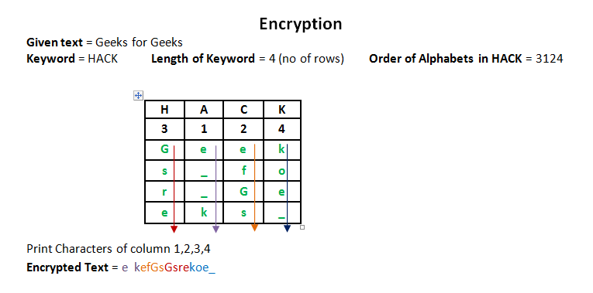

**Decryption**

* To decipher it, the recipient has to work out the column lengths by dividing the message length by the key length.
* Then, write the message out in columns again, then reorder the columns by reforming the key word.

CODE:

| import math  key = "DJSCE"  # Encryption def encryptMessage(msg):  cipher = ""  key_index = 0   msg_len = float(len(msg))  msg_lst = list(msg)  key_lst = sorted(list(key))   col = len(key)    row = int(math.ceil(msg_len / col))   fill_null = int((row * col) - msg_len)  msg_lst.extend('_' * fill_null)   matrix = [msg_lst[i: i + col]  for i in range(0, len(msg_lst), col)]   for _ in range(col):  curr_idx = key.index(key_lst[key_index])  cipher += ''.join([row[curr_idx]  for row in matrix])  key_index += 1   return cipher  # Decryption def decryptMessage(cipher):  decrypted_message = ""   key_index = 0  msg_indx = 0  msg_len = float(len(cipher))  msg_lst = list(cipher)   col = len(key)    row = int(math.ceil(msg_len / col))  key_lst = sorted(list(key))   deciphered_cipher_message = []  for _ in range(row):  deciphered_cipher_message += [[None] * col]   for _ in range(col):  curr_idx = key.index(key_lst[key_index])   for j in range(row):  deciphered_cipher_message[j][curr_idx] = msg_lst[msg_indx]  msg_indx += 1  key_index += 1   try:  decrypted_message = ''.join(sum(deciphered_cipher_message, []))  except TypeError:  raise TypeError("This program cannot",  "handle repeating words.")   null_count = decrypted_message.count('_')   if null_count > 0:  return decrypted_message[: -null_count]   return decrypted_message  msg = "Junaid Girkar" print("\nPlaintext Message:", msg)  cipher = encryptMessage(msg) print("\nCiphertext Message: {}".format(cipher))  decrypted_message = decryptMessage(cipher) print("\nDecryped Message: {}\n".format(decrypted_message)) |
| --- |

OUTPUT:

| Plaintext Message: Junaid Girkar  Ciphertext Message: ai_Jdkir_u anGr  Decryped Message: Junaid Girkar |
| --- |

**CONCLUSION**

With the increasing amount of data being generated, it is very important that confidential information does not get leaked and is read by the intended recipient.We learnt about the Columnar Transposition Cipher algorithm and we then wrote a python program to implement it.



**Experiment 3**

**Date of Performance :**  **Date of Submission:**

**SAP Id: 60004190057** **Name : Junaid Altaf Girkar**

**Div:** **A** **Batch : A4**

**Aim of Experiment**

Design and Implement Encryption and Decryption Algorithm for S-DES

**Theory / Algorithm / Conceptual Description**

Simplified Data Encryption Standard is a simple version of Data Encryption Standard having a 10-bit key and 8-bit plain text. It is much smaller than the DES algorithm as it takes only 8-bit plain text whereas DES takes 64-bit plain text. It is a block cipher algorithm and uses a symmetric key for its algorithm i.e. they use the same key for both encryption and decryption. It has 2 rounds for encryption which use two different keys.

The S-DES encryption algorithm takes an 8-bit block of plaintext (example: 10111101) and a 10-bit key as input and produces an 8-bit block of ciphertext as output. The S-DES decryption algorithm takes an 8-bit block of ciphertext and the same 10-bit key used to produce that ciphertext as input and produces the original 8-bit block of plaintext.

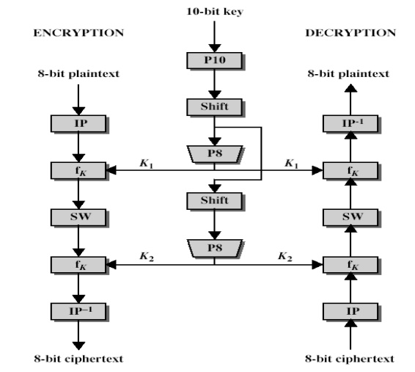

The encryption algorithm involves five functions:

* An initial permutation (IP)
* A complex function labeled fk, which involves both permutation and substitution operations and depends on a key input
* A simple permutation function that switches (SW) the two halves of the data the function fk again
* A permutation function that is the inverse of the initial permutation

The function fk takes as input not only the data passing through the encryption algorithm, but also an 8-bit key. Here a 10-bit key is used from which two 8-bit subkeys are generated. The key is first subjected to a permutation (P10). Then a shift operation is performed. The output of the shift operation then passes through a permutation function that produces an 8-bit output (P8) for the first subkey (K1). The output of the shift operation also feeds into another shift and another instance of P8 to produce the second subkey (K2).

The encryption algorithm can be expressed as a composition composition of functions: IP-1 ο fK2 ο SW ο fk1 ο IP

Which can also be written as

| Ciphertext = IP-1 (fK2 (SW (fk1 (IP (plaintext))))) |
| --- |

Where

K1 = P8 (Shift (P10 (Key)))

K2 = P8 (Shift (shift (P10 (Key))))

Decryption can be shown as

| Plaintext = IP-1 (fK1 (SW (fk2 (IP (ciphertext))))) |
| --- |

CODE:

| def apply_table(inp, table):  res = ""  for i in table:  res += inp[i - 1]  return res   def left_shift(data):  return data[1:] + data[0]   def XOR(a, b):  res = ""  for i in range(len(a)):  if a[i] == b[i]:  res += "0"  else:  res += "1"  return res   def apply_sbox(s, data):  row = int("0b" + data[0] + data[-1], 2)  col = int("0b" + data[1:3], 2)  return bin(s[row][col])[2:]   def function(expansion, s0, s1, key, message):  left = message[:4]  right = message[4:]  temp = apply_table(right, expansion)  temp = XOR(temp, key)  l = apply_sbox(s0, temp[:4])   r = apply_sbox(s1, temp[4:])  l = "0" * (2 - len(l)) + l   r = "0" * (2 - len(r)) + r  temp = apply_table(l + r, p4_table)  temp = XOR(left, temp)  return temp + right  def key_generation_1(key, table):  k = table_shift(key, table)  key_merge = split_and_merge(k)  return table_shift(key_merge, table)  def key_generation_2(key, table): return split_and_merge(key)   if __name__ == "__main__":   key = key = str('0001101101')#input("Enter 10 bit key: ")  message = "10101010"#input("Enter 8 bit message: ")  print("Plain text before decryption is : " + str(message))   p8_table = [6, 3, 7, 4, 8, 5, 10, 9]  p10_table = [3, 5, 2, 7, 4, 10, 1, 9, 8, 6]  p4_table = [2, 4, 3, 1]  IP = [2, 6, 3, 1, 4, 8, 5, 7]  IP_inv = [4, 1, 3, 5, 7, 2, 8, 6]  expansion = [4, 1, 2, 3, 2, 3, 4, 1]  s0 = [[1, 0, 3, 2], [3, 2, 1, 0], [0, 2, 1, 3], [3, 1, 3, 2]]  s1 = [[0, 1, 2, 3], [2, 0, 1, 3], [3, 0, 1, 0], [2, 1, 0, 3]]   # key generation  temp = apply_table(key, p10_table)  left = temp[:5]  right = temp[5:]  left = left_shift(left)  right = left_shift(right)  key1 = apply_table(left + right, p8_table)  left = left_shift(left)  right = left_shift(right)  left = left_shift(left)  right = left_shift(right)  key2 = apply_table(left + right, p8_table)    # encryption  temp = apply_table(message, IP)  temp = function(expansion, s0, s1, key1, temp)  temp = temp[4:] + temp[:4]  temp = function(expansion, s0, s1, key2, temp)  CT = apply_table(temp, IP_inv)  print("Cipher text is:", CT)   # decryption  temp = apply_table(CT, IP)  temp = function(expansion, s0, s1, key2, temp)  temp = temp[4:] + temp[:4]  temp = function(expansion, s0, s1, key1, temp)  PT = apply_table(temp, IP_inv)  print("Plain text after decrypting is:", PT) |
| --- |

OUTPUT:

| Plain text before decryption is : 10101010 Cipher text is: 00011111 Plain text after decrypting is: 10101010 |
| --- |

**CONCLUSION**

With the increasing amount of data being generated, it is very important that confidential information does not get leaked and is read by the intended recipient.We learnt about the Simplified DES algorithm and we then wrote a python program to implement it.

SBD Encryption Algorithm

Kanaad Deshpande

*Department of Computer Engineering D.J Sanghavi College of Engineering* Mumbai, India

26kanaad@gmail.com

Junaid Girkar

*Department of Computer Engineering D.J Sanghavi College of Engineering* Mumbai, India

junaidgirkar@gmail.com

Dr. Ramchandra Mangrulkar *Department of Computer Engineering D.J Sanghvi College of Engineering* Mumbai, India

ramchandra.mangrulkar@djsce.ac.in

*Abstract*—This document is a research paper on a new type of data encryption algorithm which makes use of a Sudoku, an everyday object, as its encryption key. It can encryption multiple types of data be it a file, an image or simple plaintext. The encryption process involves multiple rounds of block cipher encryption and transposition cipher encryption based on a randomly generated Sudoku resulting in the data being encrypted better than some of the other commonly used encryption tech niques.

*Index Terms*—encryption, cipher, block cipher, transposition cipher, image encryption, Sudoku

I. INTRODUCTION

With the rise in data being shared over the internet, data security has been gaining more importance day by day and new algorithms are being developed daily to ensure the data is being sent securely. This paper introduces a new way of encrypting multiple types of data files using an everyday objects [?] as the key.

II. PROPOSED METHODOLOGY

*A. General Process*

The encryption algorithm is based on a set of recurring patterns in everyday objects. One of the most popular such item is the 9 x 9 Sudoku puzzle that is available in almost all newspapers. It has a fixed pattern sequence where all the numbers from 0 - 9 must be there in each row, in each column and in each sub-blocks of 3 x 3. This data encryption algorithm is a combination of block cipher [?] and transposition ciphers [4] where the data goes through multiple rounds of encryption.

*B. Image Encrytion*

For image encryption [5], the algorithm takes a RGB color image [6] which it converts into a series of 9 x 9 matrices. For each matrix the algorithm then generates a random Sudoku us ing the Sudokugen python library. Using the rows and columns of the randomly generated Sudoku as the transposition key, the rows and columns of the image matrix are transpositioned multiple times to ensure a higher level of encryption.

*C. Text Encryption*

For text encryption, similar to the image encryption, the plain text is converted into matrices of 9 x 9. Then using the Sudokugen library, a random transposition key is generated.

Looping through the key, row transposition and column trans position is applied multiple times to generate the encrypted cipher text.

*D. Block Diagram*

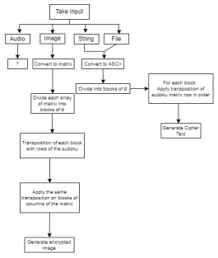Figure 1. Block Diagram.

*E. Algorithm*

Algorithm 1 Add padding around image

0: procedure SBDPADDING( *m ge, p dd ngV e*) 0: if *he ght <* 81 then

0: add padding 81 - height

0: else if  *dth <* 81 then

0: add padding 81 - width

0: else if *he ghtmod*81! **=** 0 then

0: add padding (height//81+1)*81 - height 0: else if  *dthmod*81! **=** 0 then

0: add padding (width//81+1)*81 - width

=0

Algorithm 2 Encrypt image

0: procedure SBDPADDING( *m ge, key*)

0: Generate random Sudoku.

0: Solve the Sudoku to generate the key.

0: For each row in Sudoku:

0: Generate random Sudoku.

0: Solve the Sudoku to generate the key

1: for *e chro nS dok* do

2: for *e chb ockoƒ*9*b ts* do

2: apply permutation to each block of 9 bits for each row

3: end for

4: end for

5: for *e chco mn nS dok* do

6: for *e ch*9 **−** *b tb ockoƒ co mnoƒ m ge* do 6: apply permutation to each column of image for each column of Sudoku

7: end for

8: end for

=0

III. EXPERIMENTATION

It has been observed that any traditional art form including but not limited to various objects, games or mathematical models that creates a pattern can be used for encipherment. Further study shows that a Sudoku based approach of en cipherment, involving pixel scattering encrypted the original data beyond recognition in the image after several iterations of applying the encryption algorithm. The number of iterations can be decided based on how much scattering is required for each image. Having a flexible number of iterations makes the algorithm computationally heavy, yet secure. Experimentation with various Sudokus followed. This involved using different keys for each iteration based on the 6 quintillion options available.

IV. COMPARISON WITH OTHER ALGORITHMS *A. Comparison with S-DES*

The S-DES algorithm [7] doesn’t work well with symmetric images. This is because the algorithm is applied uniformly to every single pixel. The output generated hence contains pixels uniformly scattered in the plane. Sudoku-based encryption

offers a flexible number of iterations so we loop through until a completely unrecognizable image is formed.



Figure 2. Original Image

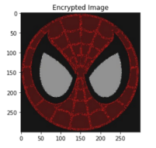Figure 3. S-DES Encryption of Symmetric Image

**+** *b* **=** *γ* (1)



Figure 4. Sudoku-Based Encryption of Symmetric Image After 1000 Itera tions

V. ATTACKING THE ALGORITHM

*A. Brute Force Attack*

Considering a brute force attack on the algorithm, the attacker first has to find the randomly generated 9 x 9 Sudoku key. This has a possibility of 1 in 6,670,903,752,021,072,936,960 cases. Even with a powerful device, it would take an extremely long time to try all the possible combinations in order to find the correct one as they will have to run the algorithm through a high number of randomly generated layers of decryption whose count will need to be separately brute forced.

Even if we consider the one in sextillion chance that an attacker manages to guess the randomly generated key using the brute force algorithm, the attacker would gain access to the first 324 bits of data only. For the remaining data, the attacker has to again brute force for the other randomly generated 9 x 9 key.

So brute forcing this algorithm has an infinitesimally chance of success and the return per success is also very less.

*B. Results*

The algorithm was tested on several iterations - 10, 50, 100, 250, 400, 500, 750, 1000 and the following results were obtained:

Table I

COMPARISON OF ITERATIONS

| Number of iterations | Time Required |
| --- | --- |
| 10  50  100  250  400  500  750  1000 | 2.658229500000001 11.760182800000003 25.154778399999998 62.587474000000014 105.29135510000003 131.0632736  217.96522460000006 287.7479881999998 |

It can be observed that the algorithm takes nearly nearly 5 minutes to complete a thousand iterations, which shows its

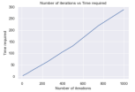

Figure 5. Time Analysis

computational inefficiency, which is a trade-off when it comes to security.



Figure 6. Image with padding after first iteration



Figure 7. Image after 10 iterations

 

Figure 8. Image after 100 iterations

Figure 11. Image after 500 iterations

 

Figure 9. Image after 250 iterations Figure 12. Image after 750 iterations

 

Figure 10. Image after 400 iterations

Figure 13. Image after 1000 iterations

ACKNOWLEDGMENT

We would like to express our gratitude to Department of Computer Engineering at Dwarkadas J Sanghvi College of Engineering who motivated us to dive into research and guided us when we faced any difficulty.

REFERENCES

[1] Mousavi, Maryam, and Babak Sadeghiyan. ”A new image encryption scheme with Feistel like structure using chaotic S-box and Rubik cube based P-box.” Multimedia Tools and Applications 80.9 (2021): 13157-13177.

[2] Wang, Xu, et al. ”Multi-level reversible data hiding for crypto imagery via a block-wise substitution-transposition cipher.” Journal of Information Security and Applications 64 (2022): 103067.

[3] Jose A.P. Artiles, Daniel P.B. Chaves, and Cecilio Pimentel. ´ 2019. Image encryption using block cipher and chaotic sequences. ¡i¿Image Commun.¡/i¿ 79, C (Nov 2019), 24–31. https://doi.org/10.1016/j.image.2019.08.014

[4] Djamalilleil, As’ad Muslim, Muslim Salim, Yulita Alwi, Erick Azis, Huzain Herman,. (2018). Modified Transposition Cipher Algorithm for Images Encryption. 1-4. 10.1109/EIConCIT.2018.8878326.

[5] Zia, U., McCartney, M., Scotney, B. et al. Survey on image encryption techniques using chaotic maps in spatial, transform and spatiotemporal domains. Int. J. Inf. Secur. (2022). https://doi.org/10.1007/s10207-022- 00588-5

[6] Al-Roithy, Budoor Obid, and Adnan Gutub. ”Remodeling randomness prioritization to boost-up security of RGB image encryption.” Multimedia Tools and Applications 80.18 (2021): 28521-28581.

[7] Kumar, Sanjay, and Sandeep Srivastava. ”Image encryption using simplified data encryption standard (S-DES).” International Journal of Computer Applications 104.2 (2014).

**Experiment 5**

**Date of Performance :**  **Date of Submission:**

**SAP Id: 60004190057** **Name : Junaid Altaf Girkar**

**Div:** **A** **Batch : A4**

**Aim of Experiment**

Design and Implement Encryption and Decryption Algorithm for RSA Algorithm

**Theory / Algorithm / Conceptual Description**

RSA algorithm is an asymmetric cryptography algorithm. Asymmetric actually means that it works on two different keys i.e. Public Key and Private Key. As the name describes, the Public Key is given to everyone and the Private key is kept private.

The idea of RSA is based on the fact that it is difficult to factorize a large integer. The public key consists of two numbers where one number is multiplication of two large prime numbers. And private keys are also derived from the same two prime numbers. So if somebody can factorize the large number, the private key is compromised. Therefore encryption strength totally lies on the key size and if we double or triple the key size, the strength of encryption increases exponentially. RSA keys can be typically 1024 or 2048 bits long, but experts believe that 1024 bit keys could be broken in the near future. But till now it seems to be an infeasible task.

**PUBLIC KEY GENERATION:**

| Select two prime no's. Suppose P = 53 and Q = 59. Now First part of the Public key : n = P*Q = 3127.  We also need a small exponent say e :   But e Must be An integer.  Not be a factor of n.   1 < e < Φ(n) [Φ(n) is discussed below],  Let us now consider it to be equal to 3. Our Public Key is made of n and e |
| --- |
|  |

**PRIVATE KEY GENERATION**

| We need to calculate Φ(n) : Such that Φ(n) = (P-1)(Q-1)   so, Φ(n) = 3016   Now calculate Private Key, d :  d = (k*Φ(n) + 1) / e for some integer k For k = 2, value of d is 2011. |
| --- |

**ENCRYPTION**:

| Convert letters to numbers : H = 8 and I = 9   Thus Encrypted Data c = 89e mod n.  Thus our Encrypted Data comes out to be 1394 |
| --- |

**DECRYPTION**:

| **Now we will decrypt 1394 :  Decrypted Data = cd mod n.  Thus our Encrypted Data comes out to be 89 8 = H and I = 9 i.e. "HI".** |
| --- |

**CODE**:

| import numpy as np import random import cv2 import matplotlib.pyplot as plt  # Select 2 prime numbers  p = 19 q = 13  # First public key n = p * q  def gcd(a, b):    if (a == 0):  return b  return gcd(b % a, a)  def phi(n):    result = 1  for i in range(2, n):  if (gcd(i, n) == 1):  result+=1  return result  # Calculating Phi(n) phi_n = phi(n) # e = random.randint(0, phi_n) e = 5  pulbic_key = (n, e) # k = random.randint(1, 10) k = 4  d = (k * phi_n + 1) / (e) private_key = d  image = cv2.imread('RSA.jpg', 0) image.shape  plt.imshow(image)   # display that image plt.show() def encrypt(input, e = 5, n = 247):  cipher = pow(input, e) % n  return cipher  shape = image.shape pixels = image.flatten() enc = []  for pixel in pixels:  enc.append(encrypt(int(pixel)))  enc = np.array(enc)  encrypted_image = enc.reshape(shape)  cv2.imwrite('rsa_encryption.jpg', encrypted_image) def decryption(encrypted, d=173, n=247):  return pow(encrypted, int(d)) % n  #DECRYPTION: image2 = cv2.imread('rsa_encryption.jpg', 0) pixels_enc = encrypted_image.flatten() image2 og = []  for pixel in pixels_enc:  og.append(decryption(int(pixel)))  og = np.array(og)  original_image = og.reshape(shape) original_image cv2.imwrite('decrypted.jpg', original_image) plt.imshow(original_image, cmap='gray') # display that image plt.show() |
| --- |

**OUTPUT**:



ORIGINAL ENCRYPTED DECRYPTED

**CONCLUSION**

With the increasing amount of data being generated, it is very important that confidential information does not get leaked and is read by the intended recipient.We learnt about asymmetric key ciphers and the RSA algorithm and we then wrote a python program to implement it.

**Experiment 6**

**Date of Performance :**  **Date of Submission:**

**SAP Id: 60004190057** **Name : Junaid Altaf Girkar**

**Div:** **A** **Batch : A4**

**Aim of Experiment**

Design and Implement Diffie Hellman Key Exchange Algorithm

**Theory:**

The Diffie-Hellman algorithm is being used to establish a shared secret that can be used for secret communications while exchanging data over a public network using the elliptic curve to generate points and get the secret key using the parameters.

For the sake of simplicity and practical implementation of the algorithm, we will consider only 4 variables, one prime P and G (a primitive root of P) and two private values a and b.

P and G are both publicly available numbers. Users (say Alice and Bob) pick private values a and b and they generate a key and exchange it publicly. The opposite person receives the key and that generates a secret key, after which they have the same secret key to encrypt.

**Implementation Example:**

| **Step 1: Alice and Bob get public numbers P = 23, G = 9  Step 2: Alice selected a private key a = 4 and  Bob selected a private key b = 3  Step 3: Alice and Bob compute public values  Alice: x =(9^4 mod 23) = (6561 mod 23) = 6  Bob: y = (9^3 mod 23) = (729 mod 23) = 16  Step 4: Alice and Bob exchange public numbers  Step 5: Alice receives public key y =16 and  Bob receives public key x = 6  Step 6: Alice and Bob compute symmetric keys  Alice: ka = y^a mod p = 65536 mod 23 = 9  Bob: kb = x^b mod p = 216 mod 23 = 9  Step 7: 9 is the shared secret.** |
| --- |

**CODE:**

| from random import randint  # Both the persons will be agreed upon the # public keys Q and P # A prime number P is taken P = 23  # A primitive root for P, Q is taken Q = 9   print('The Value of P is :%d'%(P)) print('The Value of Q is :%d'%(Q))  # Alice will choose the private key a a = 4 print('The Private Key a for Alice is :%d'%(a))  # gets the generated key x = int(pow(Q,a,P))  # Bob will choose the private key b b = 3 print('The Private Key b for Bob is :%d'%(b))  # gets the generated key y = int(pow(Q,b,P))   # Secret key for Alice ka = int(pow(y,a,P))  # Secret key for Bob kb = int(pow(x,b,P))  print('Secret key for the Alice is : %d'%(ka)) print('Secret Key for the Bob is : %d'%(kb)) |
| --- |

**OUTPUT:**

| The Value of P is :23 The Value of Q is :9 The Private Key a for Alice is :4 The Private Key b for Bob is :3 Secret key for the Alice is : 9 Secret Key for the Bob is : 9 The Value of P is :23 The Value of Q is :9 The Private Key a for Alice is :4 The Private Key b for Bob is :3 Secret key for the Alice is : 9 Secret Key for the Bob is : 9 |
| --- |

**CONCLUSION**

Even while using ciphers for encryption, it is crucial that the key for encryption and decryption is secure and yet available to the sender and receiver. Diffie Hellman key exchange algorithm is an algorithm in which even the sender and receiver are unaware of others private key. We learnt about this algorithm and implemented it in Python

**Experiment 7**

**Date of Performance :**  **Date of Submission:**

**SAP Id: 60004190057** **Name : Junaid Altaf Girkar**

**Div:** **A** **Batch : A4**

**Aim of Experiment**

Study the use of network reconnaissance tools like WHOIS, dig, traceroute, nslookup to gather information about networks and domain registrars.

**Theory:**

**WHOIS**:

WHOIS is a TCP-based query and response protocol that is commonly used to provide information services to Internet users. It returns information about the registered Domain Names, an IP address block, Name Servers and a much wider range of information services.

| **Whois v1.21 - Domain information lookup Copyright (C) 2005-2019 Mark Russinovich Sysinternals - www.sysinternals.com  Connecting to COM.whois-servers.net...  WHOIS Server: whois.markmonitor.com  Registrar URL: http://www.markmonitor.com  Updated Date: 2019-09-09T15:39:04Z  Creation Date: 1997-09-15T04:00:00Z  Registry Expiry Date: 2028-09-14T04:00:00Z  Registrar: MarkMonitor Inc.  Registrar IANA ID: 292  Registrar Abuse Contact Email: abusecomplaints@markmonitor.com  Registrar Abuse Contact Phone: +1.2086851750  Domain Status: clientDeleteProhibited https://icann.org/epp#clientDeleteProhibited  Domain Status: clientTransferProhibited https://icann.org/epp#clientTransferProhibited  Domain Status: clientUpdateProhibited https://icann.org/epp#clientUpdateProhibited  Domain Status: serverDeleteProhibited https://icann.org/epp#serverDeleteProhibited  Domain Status: serverTransferProhibited https://icann.org/epp#serverTransferProhibited  Domain Status: serverUpdateProhibited https://icann.org/epp#serverUpdateProhibited  Name Server: NS1.GOOGLE.COM  Name Server: NS2.GOOGLE.COM  Name Server: NS3.GOOGLE.COM  Name Server: NS4.GOOGLE.COM  DNSSEC: unsigned  URL of the ICANN Whois Inaccuracy Complaint Form: https://www.icann.org/wicf/ >>> Last update of whois database: 2022-06-02T15:50:49Z <<<  For more information on Whois status codes, please visit https://icann.org/epp  NOTICE: The expiration date displayed in this record is the date the registrar's sponsorship of the domain name registration in the registry is currently set to expire. This date does not necessarily reflect the expiration date of the domain name registrant's agreement with the sponsoring registrar. Users may consult the sponsoring registrar's Whois database to view the registrar's reported date of expiration for this registration.  TERMS OF USE: You are not authorized to access or query our Whois database through the use of electronic processes that are high-volume and automated except as reasonably necessary to register domain names or modify existing registrations; the Data in VeriSign Global Registry Services' ("VeriSign") Whois database is provided by VeriSign for information purposes only, and to assist persons in obtaining information about or related to a domain name registration record. VeriSign does not guarantee its accuracy. By submitting a Whois query, you agree to abide by the following terms of use: You agree that you may use this Data only for lawful purposes and that under no circumstances will you use this Data to: (1) allow, enable, or otherwise support the transmission of mass unsolicited, commercial advertising or solicitations via e-mail, telephone, or facsimile; or (2) enable high volume, automated, electronic processes that apply to VeriSign (or its computer systems). The compilation, repackaging, dissemination or other use of this Data is expressly prohibited without the prior written consent of VeriSign. You agree not to use electronic processes that are automated and high-volume to access or query the Whois database except as reasonably necessary to register domain names or modify existing registrations. VeriSign reserves the right to restrict your access to the Whois database in its sole discretion to ensure operational stability. VeriSign may restrict or terminate your access to the Whois database for failure to abide by these terms of use. VeriSign reserves the right to modify these terms at any time.  The Registry database contains ONLY .COM, .NET, .EDU domains and Registrars.  Connecting to whois.markmonitor.com...  WHOIS Server: whois.markmonitor.com Registrar URL: http://www.markmonitor.com Updated Date: 2019-09-09T15:39:04+0000 Creation Date: 1997-09-15T07:00:00+0000 Registrar Registration Expiration Date: 2028-09-13T07:00:00+0000 Registrar: MarkMonitor, Inc. Registrar IANA ID: 292 Registrar Abuse Contact Email: abusecomplaints@markmonitor.com Registrar Abuse Contact Phone: +1.2083895770 Domain Status: clientUpdateProhibited (https://www.icann.org/epp#clientUpdateProhibited) Domain Status: clientTransferProhibited (https://www.icann.org/epp#clientTransferProhibited) Domain Status: clientDeleteProhibited (https://www.icann.org/epp#clientDeleteProhibited) Domain Status: serverUpdateProhibited (https://www.icann.org/epp#serverUpdateProhibited) Domain Status: serverTransferProhibited (https://www.icann.org/epp#serverTransferProhibited) Domain Status: serverDeleteProhibited (https://www.icann.org/epp#serverDeleteProhibited) Registrant Organization: Google LLC Registrant State/Province: CA Registrant Country: US Registrant Email: Select Request Email Form at https://domains.markmonitor.com/whois/google.com Admin Organization: Google LLC Admin State/Province: CA Admin Country: US Admin Email: Select Request Email Form at https://domains.markmonitor.com/whois/google.com Tech Organization: Google LLC Tech State/Province: CA Tech Country: US Tech Email: Select Request Email Form at https://domains.markmonitor.com/whois/google.com Name Server: ns1.google.com Name Server: ns4.google.com Name Server: ns3.google.com Name Server: ns2.google.com DNSSEC: unsigned URL of the ICANN WHOIS Data Problem Reporting System: http://wdprs.internic.net/ >>> Last update of WHOIS database: 2022-06-02T15:43:07+0000 <<<  For more information on WHOIS status codes, please visit:  https://www.icann.org/resources/pages/epp-status-codes  If you wish to contact this domainΓÇÖs Registrant, Administrative, or Technical contact, and such email address is not visible above, you may do so via our web form, pursuant to ICANNΓÇÖs Temporary Specification. To verify that you are not a robot, please enter your email address to receive a link to a page that facilitates email communication with the relevant contact(s).  Web-based WHOIS:  https://domains.markmonitor.com/whois  If you have a legitimate interest in viewing the non-public WHOIS details, send your request and the reasons for your request to whoisrequest@markmonitor.com and specify the domain name in the subject line. We will review that request and may ask for supporting documentation and explanation.  The data in MarkMonitorΓÇÖs WHOIS database is provided for information purposes, and to assist persons in obtaining information about or related to a domain nameΓÇÖs registration record. While MarkMonitor believes the data to be accurate, the data is provided "as is" with no guarantee or warranties regarding its accuracy.  By submitting a WHOIS query, you agree that you will use this data only for lawful purposes and that, under no circumstances will you use this data to:  (1) allow, enable, or otherwise support the transmission by email, telephone, or facsimile of mass, unsolicited, commercial advertising, or spam; or  (2) enable high volume, automated, or electronic processes that send queries, data, or email to MarkMonitor (or its systems) or the domain name contacts (or its systems).  MarkMonitor reserves the right to modify these terms at any time.  By submitting this query, you agree to abide by this policy.  MarkMonitor Domain Management(TM) Protecting companies and consumers in a digital world.  Visit MarkMonitor at https://www.markmonitor.com Contact us at +1.8007459229 In Europe, at +44.02032062220 --   Domain Name: google.com Registry Domain ID: 2138514_DOMAIN_COM-VRSN Registrar WHOIS Server: whois.markmonitor.com Registrar URL: http://www.markmonitor.com Updated Date: 2019-09-09T15:39:04+0000 Creation Date: 1997-09-15T07:00:00+0000 Registrar Registration Expiration Date: 2028-09-13T07:00:00+0000 Registrar: MarkMonitor, Inc. Registrar IANA ID: 292 Registrar Abuse Contact Email: abusecomplaints@markmonitor.com Registrar Abuse Contact Phone: +1.2083895770 Domain Status: clientUpdateProhibited (https://www.icann.org/epp#clientUpdateProhibited) Domain Status: clientTransferProhibited (https://www.icann.org/epp#clientTransferProhibited) Domain Status: clientDeleteProhibited (https://www.icann.org/epp#clientDeleteProhibited) Domain Status: serverUpdateProhibited (https://www.icann.org/epp#serverUpdateProhibited) Domain Status: serverTransferProhibited (https://www.icann.org/epp#serverTransferProhibited) Domain Status: serverDeleteProhibited (https://www.icann.org/epp#serverDeleteProhibited) Registrant Organization: Google LLC Registrant State/Province: CA Registrant Country: US Registrant Email: Select Request Email Form at https://domains.markmonitor.com/whois/google.com Admin Organization: Google LLC Admin State/Province: CA Admin Country: US Admin Email: Select Request Email Form at https://domains.markmonitor.com/whois/google.com Tech Organization: Google LLC Tech State/Province: CA Tech Country: US Tech Email: Select Request Email Form at https://domains.markmonitor.com/whois/google.com Name Server: ns1.google.com Name Server: ns4.google.com Name Server: ns3.google.com Name Server: ns2.google.com DNSSEC: unsigned URL of the ICANN WHOIS Data Problem Reporting System: http://wdprs.internic.net/ >>> Last update of WHOIS database: 2022-06-02T15:43:07+0000 <<<  For more information on WHOIS status codes, please visit:  https://www.icann.org/resources/pages/epp-status-codes  If you wish to contact this domainΓÇÖs Registrant, Administrative, or Technical contact, and such email address is not visible above, you may do so via our web form, pursuant to ICANNΓÇÖs Temporary Specification. To verify that you are not a robot, please enter your email address to receive a link to a page that facilitates email communication with the relevant contact(s).  Web-based WHOIS:  https://domains.markmonitor.com/whois  If you have a legitimate interest in viewing the non-public WHOIS details, send your request and the reasons for your request to whoisrequest@markmonitor.com and specify the domain name in the subject line. We will review that request and may ask for supporting documentation and explanation.  The data in MarkMonitorΓÇÖs WHOIS database is provided for information purposes, and to assist persons in obtaining information about or related to a domain nameΓÇÖs registration record. While MarkMonitor believes the data to be accurate, the data is provided "as is" with no guarantee or warranties regarding its accuracy.  By submitting a WHOIS query, you agree that you will use this data only for lawful purposes and that, under no circumstances will you use this data to:  (1) allow, enable, or otherwise support the transmission by email, telephone, or facsimile of mass, unsolicited, commercial advertising, or spam; or  (2) enable high volume, automated, or electronic processes that send queries, data, or email to MarkMonitor (or its systems) or the domain name contacts (or its systems).  MarkMonitor reserves the right to modify these terms at any time.  By submitting this query, you agree to abide by this policy.  MarkMonitor Domain Management(TM) Protecting companies and consumers in a digital world.  Visit MarkMonitor at https://www.markmonitor.com Contact us at +1.8007459229 In Europe, at +44.02032062220 --** |
| --- |

**DIG:**

Dig (Domain Information Groper) is a powerful command-line tool for querying DNS

name servers.The dig command, allows you to query information about various DNS

records, including host addresses, mail exchanges, and name servers. It is the most

commonly used tool among system administrators for troubleshooting DNS problems

because of its flexibility and ease of use

| **C:\Users\DELL>dig google.com  ; <<>> DiG 9.16.29 <<>> google.com ;; global options: +cmd ;; Got answer: ;; ->>HEADER<<- opcode: QUERY, status: NOERROR, id: 62757 ;; flags: qr rd ra; QUERY: 1, ANSWER: 1, AUTHORITY: 4, ADDITIONAL: 9  ;; OPT PSEUDOSECTION: ; EDNS: version: 0, flags:; udp: 4096 ;; QUESTION SECTION: ;google.com. IN A  ;; ANSWER SECTION: google.com. 157 IN A 142.251.42.14  ;; AUTHORITY SECTION: google.com. 35249 IN NS ns4.google.com. google.com. 35249 IN NS ns2.google.com. google.com. 35249 IN NS ns1.google.com. google.com. 35249 IN NS ns3.google.com.  ;; ADDITIONAL SECTION: ns1.google.com. 206783 IN A 216.239.32.10 ns1.google.com. 293783 IN AAAA 2001:4860:4802:32::a ns4.google.com. 31667 IN A 216.239.38.10 ns4.google.com. 31667 IN AAAA 2001:4860:4802:38::a ns3.google.com. 31667 IN A 216.239.36.10 ns3.google.com. 31667 IN AAAA 2001:4860:4802:36::a ns2.google.com. 204464 IN A 216.239.34.10 ns2.google.com. 204464 IN AAAA 2001:4860:4802:34::a  ;; Query time: 6 msec ;; SERVER: 192.168.1.1#53(192.168.1.1) ;; WHEN: Thu Jun 02 21:30:08 India Standard Time 2022 ;; MSG SIZE rcvd: 303** |
| --- |

| **C:\Users\DELL>dig 142.251.42.14  ; <<>> DiG 9.16.29 <<>> 142.251.42.14 ;; global options: +cmd ;; Got answer: ;; ->>HEADER<<- opcode: QUERY, status: NXDOMAIN, id: 38521 ;; flags: qr rd ra; QUERY: 1, ANSWER: 0, AUTHORITY: 1, ADDITIONAL: 1  ;; OPT PSEUDOSECTION: ; EDNS: version: 0, flags:; udp: 4096 ;; QUESTION SECTION: ;142.251.42.14. IN A  ;; AUTHORITY SECTION: . 10800 IN SOA a.root-servers.net. nstld.verisign-grs.com. 2022060200 1800 900 604800 86400  ;; Query time: 0 msec ;; SERVER: 192.168.1.1#53(192.168.1.1) ;; WHEN: Thu Jun 02 21:35:01 India Standard Time 2022 ;; MSG SIZE rcvd: 117** |
| --- |

**NSLOOKUP:**

Nslookup (stands for “Name Server Lookup”) is a useful command for getting information from DNS server. It is a network administration tool for querying the Domain Name System (DNS) to obtain domain name or IP address mapping or any other specific DNS record. It is also used to troubleshoot DNS related problems. nslookup followed by the domain name will display the “A Record” (IP Address) of the domain. Use this command to find the address record for a domain. It queries to domain name servers and get the details.

| C:\Users\junai>nslookup amazon.com Server: UnKnown Address: 192.168.0.1  Non-authoritative answer: Name: amazon.com Addresses: 176.32.103.205  54.239.28.85  205.251.242.103 |
| --- |

**SOA record** (start of authority), provides the authoritative information about the domain, the e-mail address of the domain admin, the domain serial number, etc

| C:\Users\junai>nslookup -type=soa amazon.com Server: UnKnown Address: 192.168.0.1  Non-authoritative answer: amazon.com  primary name server = dns-external-master.amazon.com  responsible mail addr = root.amazon.com  serial = 2010158906  refresh = 180 (3 mins)  retry = 60 (1 min)  expire = 3024000 (35 days)  default TTL = 60 (1 min)  amazon.com nameserver = pdns6.ultradns.co.uk amazon.com nameserver = pdns1.ultradns.net amazon.com nameserver = ns1.p31.dynect.net amazon.com nameserver = ns2.p31.dynect.net amazon.com nameserver = ns3.p31.dynect.net amazon.com nameserver = ns4.p31.dynect.net ns1.p31.dynect.net internet address = 108.59.161.31 ns2.p31.dynect.net internet address = 108.59.162.31 ns3.p31.dynect.net internet address = 108.59.163.31 ns4.p31.dynect.net internet address = 108.59.164.31 pdns1.ultradns.net internet address = 204.74.108.1 pdns6.ultradns.co.uk internet address = 204.74.115.1 ns1.p31.dynect.net AAAA IPv6 address = 2600:2000:2210::31 ns2.p31.dynect.net AAAA IPv6 address = 2600:2000:2220::31 ns3.p31.dynect.net AAAA IPv6 address = 2600:2000:2230::31 ns4.p31.dynect.net AAAA IPv6 address = 2600:2000:2240::31 pdns1.ultradns.net AAAA IPv6 address = 2001:502:f3ff::1 pdns6.ultradns.co.uk AAAA IPv6 address = 2610:a1:1017::1 |
| --- |

**NS (Name Server)** record maps a domain name to a list of DNS servers authoritative for that domain. It will output the name serves which are associated with the given domain.

| C:\Users\junai>nslookup -type=ns amazon.com Server: UnKnown Address: 192.168.0.1  Non-authoritative answer: amazon.com nameserver = pdns1.ultradns.net amazon.com nameserver = ns4.p31.dynect.net amazon.com nameserver = pdns6.ultradns.co.uk amazon.com nameserver = ns1.p31.dynect.net amazon.com nameserver = ns2.p31.dynect.net amazon.com nameserver = ns3.p31.dynect.net  ns1.p31.dynect.net internet address = 108.59.161.31 ns2.p31.dynect.net internet address = 108.59.162.31 ns3.p31.dynect.net internet address = 108.59.163.31 ns4.p31.dynect.net internet address = 108.59.164.31 pdns1.ultradns.net internet address = 204.74.108.1 pdns6.ultradns.co.uk internet address = 204.74.115.1 ns1.p31.dynect.net AAAA IPv6 address = 2600:2000:2210::31 ns2.p31.dynect.net AAAA IPv6 address = 2600:2000:2220::31 ns3.p31.dynect.net AAAA IPv6 address = 2600:2000:2230::31 ns4.p31.dynect.net AAAA IPv6 address = 2600:2000:2240::31 pdns1.ultradns.net AAAA IPv6 address = 2001:502:f3ff::1 pdns6.ultradns.co.uk AAAA IPv6 address = 2610:a1:1017::1 |
| --- |

**TRACEROUTE**:

Traceroute command in Linux prints the route that a packet takes to reach the host. This command is useful when you want to know about the route and about all the hops that a packet takes. The first column corresponds to the hop count. The second column represents the address of that hop and after that, you see three space-separated time in milliseconds. the traceroute command sends three packets to the hop and each of the time refers to the time taken by the packet to reach the hop. In windows, alternative for traceroute command is tracert.

| C:\Users\junai>tracert amazon.com  Tracing route to amazon.com [205.251.242.103] over a maximum of 30 hops:   1 3 ms 3 ms 2 ms 192.168.0.1  2 2 ms 1 ms 3 ms 42-200.59.103.n4uspl.net [103.59.200.42]  3 3 ms 2 ms 3 ms 41-200.59.103.n4uspl.net [103.59.200.41]  4 * * 3 ms 254-200.59.103.n4uspl.net [103.59.200.254]  5 6 ms 5 ms 6 ms 123.252.244.1  6 7 ms 4 ms 4 ms 10.0.10.209  7 6 ms 4 ms 5 ms 10.124.253.101  8 * * 8 ms 10.118.143.9  9 7 ms 5 ms 5 ms 115.113.165.21.static-mumbai.vsnl.net.in [115.113.165.21]  10 9 ms 7 ms 5 ms 172.23.78.237  11 5 ms 4 ms 5 ms ix-ae-0-100.tcore1.mlv-mumbai.as6453.net [180.87.38.5]  12 251 ms 201 ms 200 ms if-ae-2-2.tcore2.mlv-mumbai.as6453.net [180.87.38.2]  13 * * * Request timed out.  14 * 401 ms * if-ae-66-8.tcore3.nto-newyork.as6453.net [80.231.130.195]  15 207 ms * 202 ms if-be-2-2.ecore1.n75-newyork.as6453.net [66.110.96.62]  16 211 ms 217 ms 223 ms if-ae-57-2.tcore1.n75-newyork.as6453.net [66.110.96.58]  17 200 ms 200 ms 347 ms 66.110.96.157  18 * * * Request timed out.  19 * * * Request timed out.  20 * * * Request timed out.  21 * * * Request timed out.  22 * * * Request timed out.  23 * * * Request timed out.  24 * * * Request timed out.  25 * * * Request timed out.  26 * * * Request timed out.  27 * * * Request timed out.  28 * * * Request timed out.  29 * * * Request timed out.  30 * * * Request timed out.  Trace complete. |
| --- |

**CONCLUSION**

Thus, we have successfully implemented and studied the use of network reconnaissance tools like WHOIS, dig, traceroute, nslookup to gather information about networks and domain registrars.

**Experiment 8**

**Date of Performance :**  **Date of Submission:**

**SAP Id: 60004190057** **Name : Junaid Altaf Girkar**

**Div:** **A** **Batch : A4**

**Aim of Experiment**

Study of packet sniffer tools : wireshark, :

a. Download and install wireshark and capture icmp, tcp, and http packets in promiscuous mode.

b. Explore how the packets can be traced based on different filters. (CO5)

**Theory:**

Wireshark is a free and open-source packet analyzer. It is used for network troubleshooting, analysis, software and communications protocol development, and education. Wireshark lets the user put network interface controllers into promiscuous mode (if supported by the network interface controller), so they can see all the traffic visible on that interface including unicast traffic not sent to that network interface controller's MAC address. However, when capturing with a packet analyzer in promiscuous mode on a port on a network switch, not all traffic through the switch is necessarily sent to the port where the capture is done, so capturing in promiscuous mode is not necessarily sufficient to see all network traffic. Port mirroring or various network taps extend capture to any point on the network. Simple passive taps are extremely resistant to tampering.

**Capturing ICMP Packets:**

| C:\Users\junai>ping 8.8.8.8  Pinging 8.8.8.8 with 32 bytes of data: Reply from 8.8.8.8: bytes=32 time=5ms TTL=119 Reply from 8.8.8.8: bytes=32 time=6ms TTL=119 Reply from 8.8.8.8: bytes=32 time=2ms TTL=119 Reply from 8.8.8.8: bytes=32 time=3ms TTL=119  Ping statistics for 8.8.8.8:  Packets: Sent = 4, Received = 4, Lost = 0 (0% loss), Approximate round trip times in milli-seconds:  Minimum = 2ms, Maximum = 6ms, Average = 4ms |
| --- |

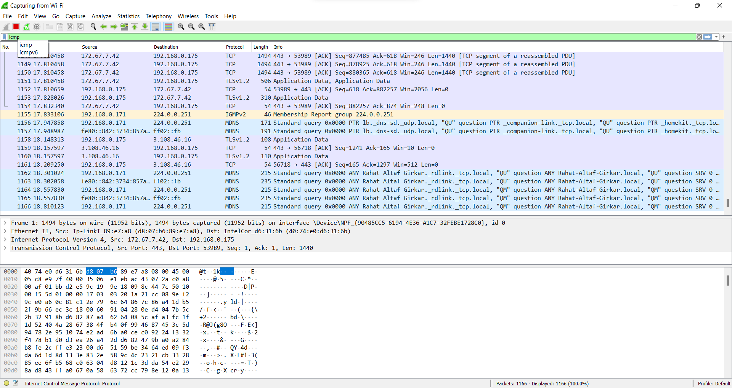

**Capturing TCP Packets:**

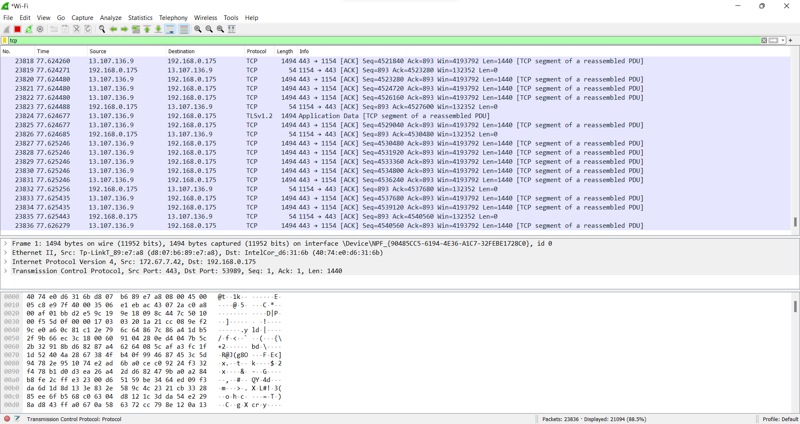

**Capturing FTP Packets:**

| C:\Users\junai>ftp ftp.cdc.gov Connected to ftp.cdc.gov. 220 Microsoft FTP Service 200 OPTS UTF8 command successful - UTF8 encoding now ON. User (ftp.cdc.gov:(none)): anonymous 331 Anonymous access allowed, send identity (e-mail name) as password. Password: 230 User logged in. ftp> ls 200 PORT command successful. 150 Opening ASCII mode data connection. .change.dir .message pub Readme Siteinfo w3c welcome.msg 226 Transfer complete. ftp: 67 bytes received in 0.03Seconds 2.03Kbytes/sec. |
| --- |

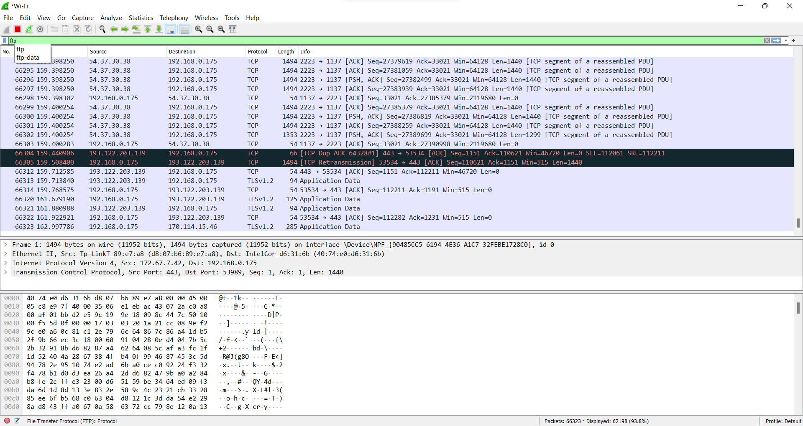

**Capturing ARP Packets:**

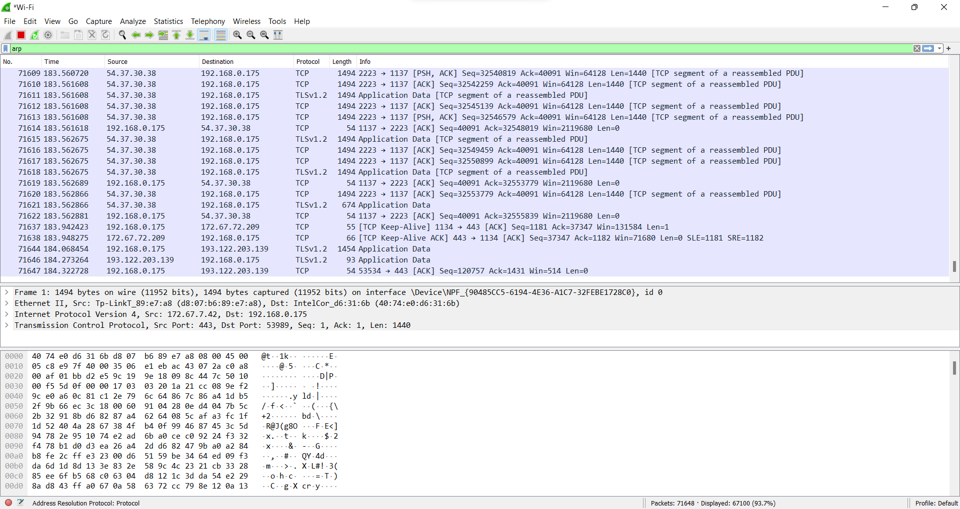

**B] Tracing Packets based on filters:**

**1] Filter Results by Port:**

**Traces all packets related to Port 80.**

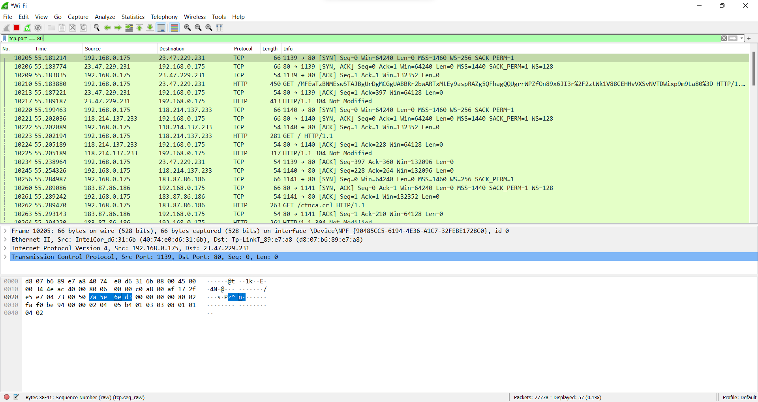

**2] Filter by Delta Time :**

**Displays tcp packets with delta time of greater than 0.500 sec**

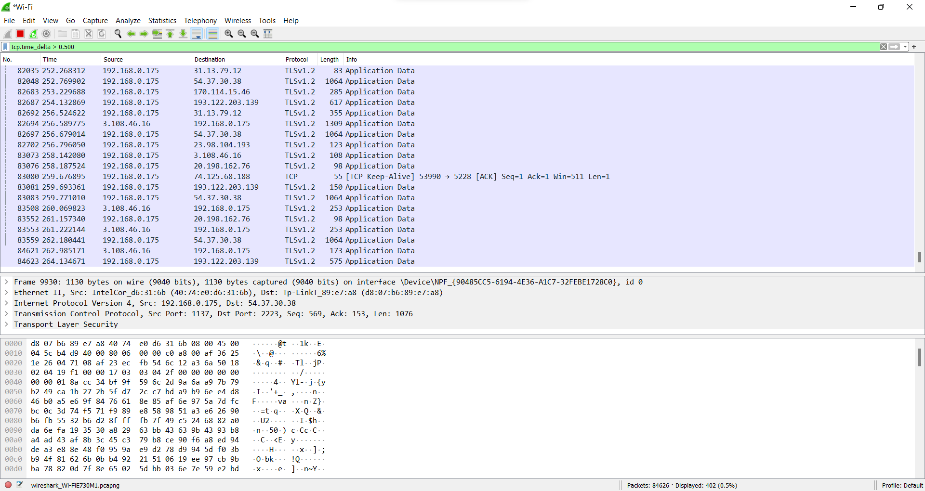

**3] Filter by Byte Sequence:**

**Displays packets which contain a particular byte sequence.**

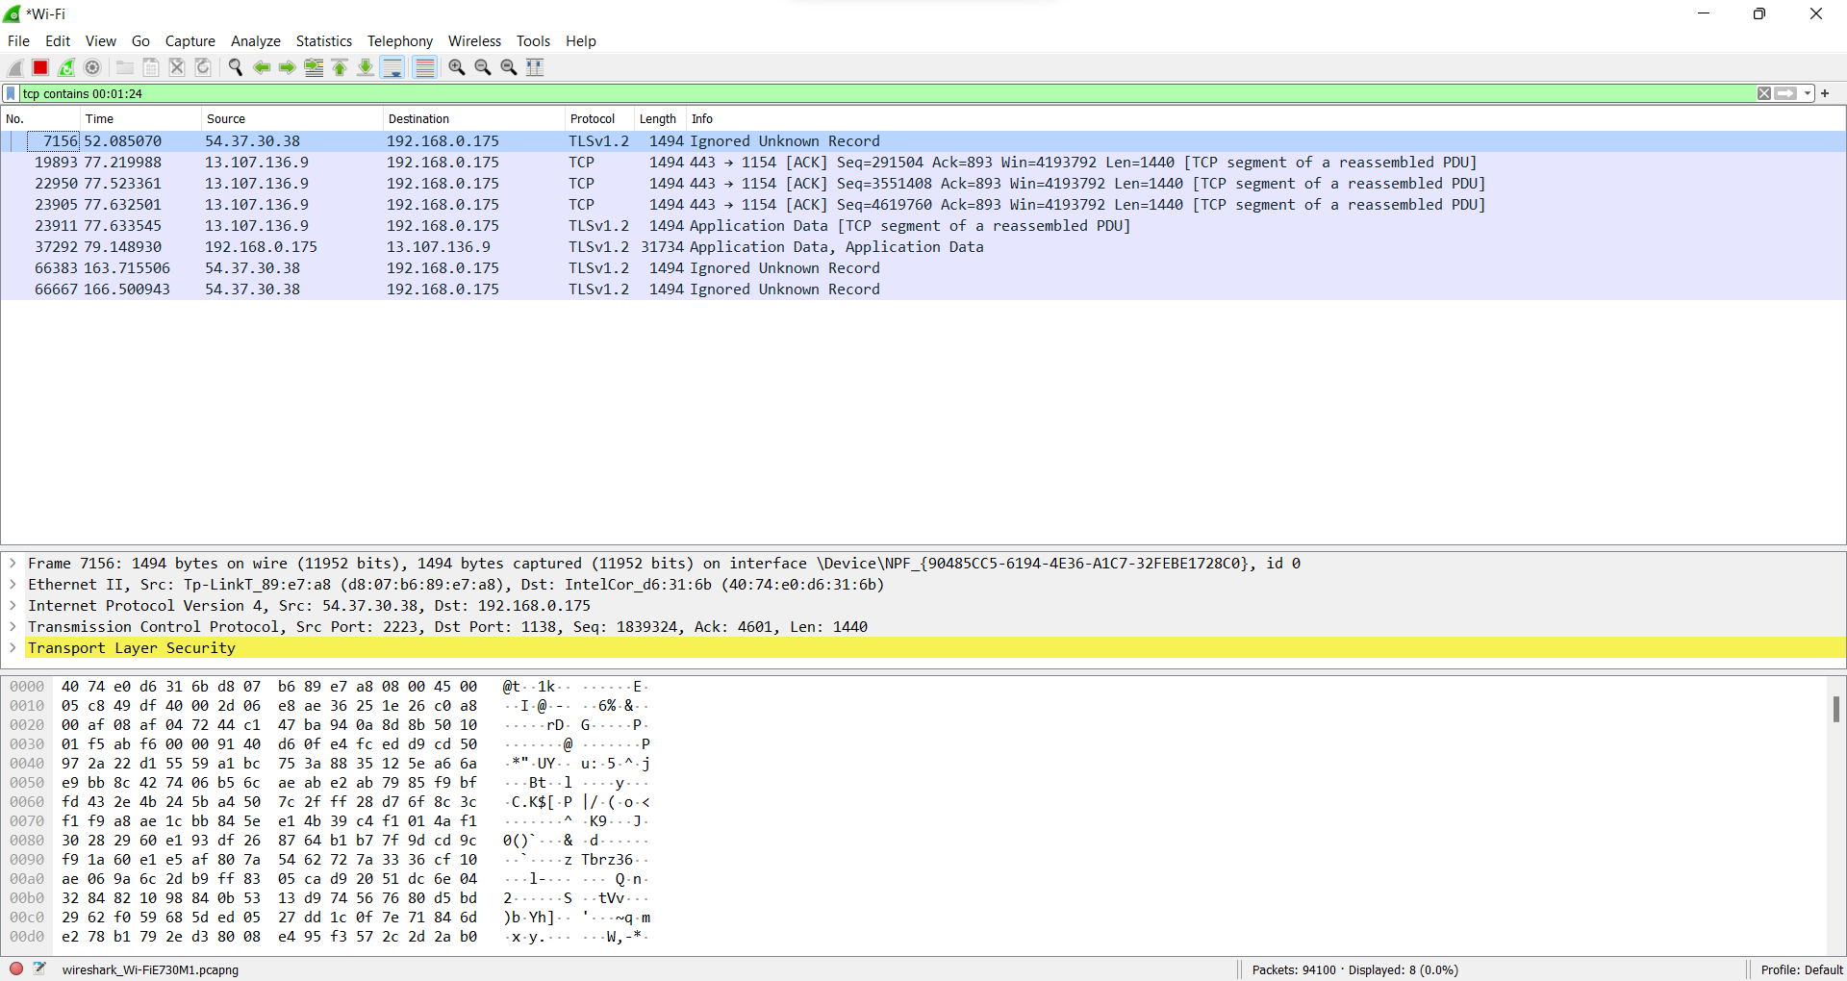

**4] Filter by Source IP Address:**

**Displays packets which have source IP address same as the one provided in the argument.**

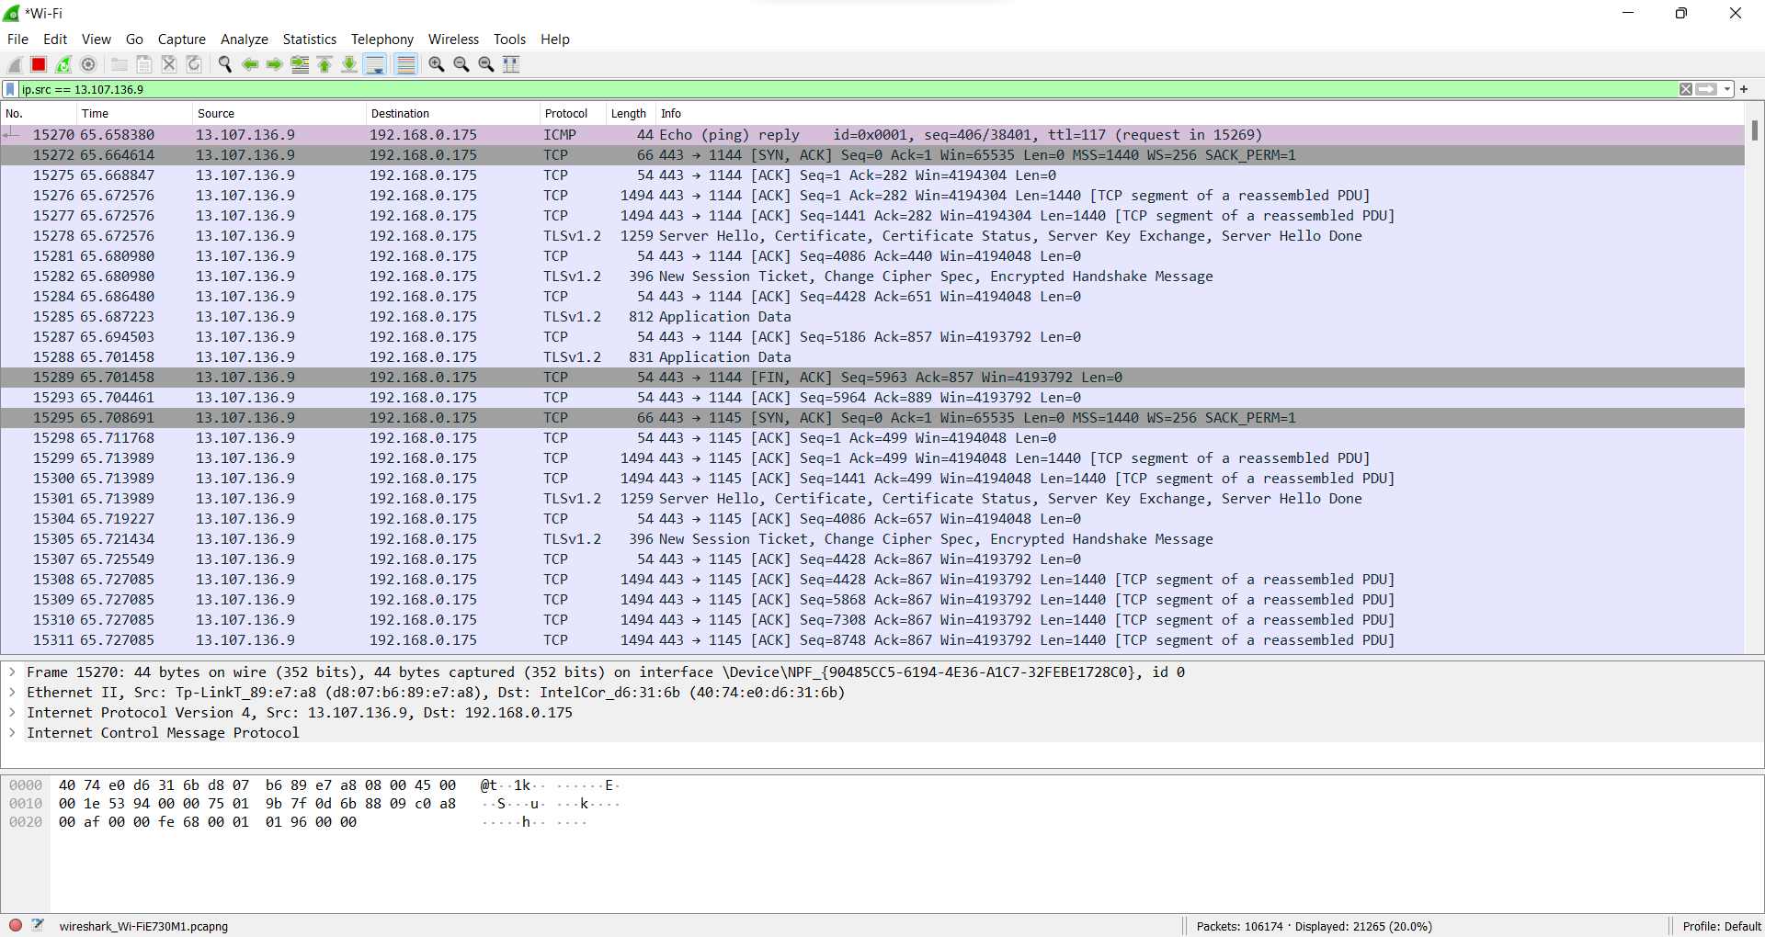

**CONCLUSION**

Thus, we have successfully studied packet sniffing tools (wireshark) and explored how packets can be traced on the basis of different filters.

**Experiment 9**

**Date of Performance :**  **Date of Submission:**

**SAP Id: 60004190057** **Name : Junaid Altaf Girkar**

**Div:** **A** **Batch : A4**

**Aim of Experiment**

Implementation of Network Intrusion Detection System using NMAP, SNORT and IPTABLE (CO6).

**Theory:**

**IPTables:**

iptables is a user-space utility program that allows a system administrator to configure the IP packet filter rules of the Linux kernel firewall, implemented as different Netfilter modules. The filters are organized in different tables, which contain chains of rules for how to treat network traffic packets. Different kernel modules and programs are currently used for different protocols; iptables applies to IPv4, ip6tables to IPv6, arptables to ARP, and ebtables to Ethernet frames.

**NMAP:**

Nmap, short for Network Mapper, is a free, open-source tool for vulnerability scanning and network discovery. Network administrators use Nmap to identify what devices are running on their systems, discovering hosts that are available and the services they offer, finding open ports and detecting security risks. Nmap can be used to monitor single hosts as well as vast networks that encompass hundreds of thousands of devices and multitudes of subnets.

| **C:\Users\junai>nmap 10.120.63.29 -O -sV -p 20-25 -Pn Starting Nmap 7.92 ( https://nmap.org ) at 2022-06-03 00:35 India Standard Time Nmap scan report for 10.120.63.29 Host is up.  PORT STATE SERVICE VERSION 20/tcp filtered ftp-data 21/tcp filtered ftp 22/tcp filtered ssh 23/tcp filtered telnet 24/tcp filtered priv-mail 25/tcp filtered smtp Too many fingerprints match this host to give specific OS details  OS and Service detection performed. Please report any incorrect results at https://nmap.org/submit/ . Nmap done: 1 IP address (1 host up) scanned in 13.49 seconds** |
| --- |

| **C:\Users\junai>nmap 10.120.63.29 10.120.63.28 -sL Starting Nmap 7.92 ( https://nmap.org ) at 2022-06-03 00:36 India Standard Time Nmap scan report for 10.120.63.29 Nmap scan report for 10.120.63.28 Nmap done: 2 IP addresses (0 hosts up) scanned in 0.10 seconds** |
| --- |

| **C:\Users\junai>nmap 10.120.63.29 -p 21,22,23,25,80 -Pn Starting Nmap 7.92 ( https://nmap.org ) at 2022-06-03 00:37 India Standard Time Nmap scan report for 10.120.63.29 Host is up.  PORT STATE SERVICE 21/tcp filtered ftp 22/tcp filtered ssh 23/tcp filtered telnet 25/tcp filtered smtp 80/tcp filtered http  Nmap done: 1 IP address (1 host up) scanned in 3.39 seconds** |
| --- |

**SNORT:**

Snort is a free and open-source network intrusion prevention and detection system.

It uses a rule-based language combining signature, protocol, and anomaly inspection

methods to detect malicious activity such as denial-of-service (DoS) attacks, Buffer

overflows, stealth port scans, CGI attacks, SMB probes, and OS fingerprinting attempts.

It is capable of performing real-time traffic analysis and packet logging on IP networks.

**IP Protocols supported by SNORT:**

As we know, IP is a unique address for every computer and is used for transferring data or packets over the internet from one network to the other network. Each packet contains a message, data, source, destination address, and much more. Snort supports three IP protocols for suspicious behavior:

● Transmission Control Protocol (TCP) Connects two different hosts and exchanges data between them. Examples include HTTP, SMTP, and FTP.

● User Datagram Protocol (UDP): Broadcasts messages over the internet. Examples include DNS traffic.

● Internet Control Message Protocol (ICMP): Sends network error messages in Windows. Examples include Ping and Traceroute.

**Snort Rules:**

Rules are a different methodology for performing detection, which bring the advantage of 0-day detection to the table. Developing a rule requires an acute understanding of how the vulnerability actually works. Snort generates alerts according to the rules defined in the configuration file. The Snort rule language is very flexible, and creation of new rules is relatively simple. Snort rules help in differentiating between normal internet activities and malicious activities

**ICMP Intrusion Detection:**

| **C:\Snort\bin>snort -c C:\Snort\etc\snort.conf -l C:\Snort\log -i2 -T Running in Test mode   --== Initializing Snort ==-- Initializing Output Plugins! Initializing Preprocessors! Initializing Plug-ins! Parsing Rules file "C:\Snort\etc\snort.conf" PortVar 'HTTP_PORTS' defined : [ 80:81 311 383 591 593 901 1220 1414 1741 1830 2301 2381 2809 3037 3128 3702 4343 4848 5250 6988 7000:7001 7144:7145 7510 7777 7779 8000 8008 8014 8028 8080 8085 8088 8090 8118 8123 8180:8181 8243 8280 8300 8800 8888 8899 9000 9060 9080 9090:9091 9443 9999 11371 34443:34444 41080 50002 55555 ] PortVar 'SHELLCODE_PORTS' defined : [ 0:79 81:65535 ] PortVar 'ORACLE_PORTS' defined : [ 1024:65535 ] PortVar 'SSH_PORTS' defined : [ 22 ] PortVar 'FTP_PORTS' defined : [ 21 2100 3535 ] PortVar 'SIP_PORTS' defined : [ 5060:5061 5600 ] PortVar 'FILE_DATA_PORTS' defined : [ 80:81 110 143 311 383 591 593 901 1220 1414 1741 1830 2301 2381 2809 3037 3128 3702 4343 4848 5250 6988 7000:7001 7144:7145 7510 7777 7779 8000 8008 8014 8028 8080 8085 8088 8090 8118 8123 8180:8181 8243 8280 8300 8800 8888 8899 9000 9060 9080 9090:9091 9443 9999 11371 34443:34444 41080 50002 55555 ] PortVar 'GTP_PORTS' defined : [ 2123 2152 3386 ] Detection:  Search-Method = AC-Full-Q  Split Any/Any group = enabled  Search-Method-Optimizations = enabled  Maximum pattern length = 20** |
| --- |

**CONCLUSION**

Thus, we have successfully implemented a Network Intrusion Detection System using NMAP, SNORT and IPTables.

**Experiment 10**

**Date of Performance :**  **Date of Submission:**

**SAP Id: 60004190057** **Name : Junaid Altaf Girkar**

**Div:** **A** **Batch : A4**

**Aim of Experiment**

Implement Buffer Overflow Attack. (CO7)

**Theory:**

**Buffer Overflow Attack:**

Attackers exploit buffer overflow issues by overwriting the memory of an application. This changes the execution path of the program, triggering a response that damages files or exposes private information. For example, an attacker may introduce extra code, sending new instructions to the application to gain access to IT systems. If attackers know the memory layout of a program, they can intentionally feed input that the buffer cannot store, and overwrite areas that hold executable code, replacing it with their own code. For example, an attacker can overwrite a pointer (an object that points to another area in memory) and point it to an exploit payload, to gain control over the program. Stack-based buffer overflows are more common, and leverage stack memory that only exists during the execution time of a function. Heap-based attacks are harder to carry out and involve flooding the memory space allocated for a program beyond memory used for current runtime operations.

**Ollydbg:**

OllyDbg (named after its author, Oleh Yuschuk) is an x86 debugger that emphasizes binary code analysis, which is useful when source code is not available. It traces registers, recognizes procedures, API calls, switches, tables, constants and strings, as well as locates routines from object files and libraries. It has a user friendly interface, and its functionality can be extended by third-party plugins. OllyDbg is often used for reverse engineering of programs. It is often used by crackers to crack software made by other developers. For cracking and reverse engineering, it is often the primary tool because of its ease of use and availability; any 32-bit executable can be used by the debugger and edited in bitcode/assembly in realtime.It is also useful for programmers to ensure that their program is running as intended, and for malware analysis purposes.

**Splint:**

Splint is a tool for statically checking C programs for security vulnerabilities and coding mistakes. With minimal effort, Splint can be used as a better lint. If additional effort is invested adding annotations to programs, Splint can perform stronger checking than can be done by any standard lint. Splint has the ability to interpret special annotations to the source code, which gives it stronger checking than is possible just by looking at the source alone. Splint is used by gpsd as part of an effort to design for zero defects.

**Cppcheck:**

Cppcheck is a static code analysis tool for the C and C++ programming languages. It is a versatile tool that can check non-standard code. Cppcheck supports a wide variety of static checks that may not be covered by the compiler itself. These checks are static analysis checks that can be performed at a source code level. The program is directed towards static analysis checks that are rigorous, rather than heuristic in nature. Some of the checks that are supported include:

• Automatic variable checking

• Bounds checking for array overruns

• Classes checking (e.g. unused functions, variable initialization and memory duplication)

CODE:

Code with Buffer Overflow

| #include <stdio.h> #include <string.h>  #define UP_MAXLEN 20 #define UP_PAIR_COUNT 3 int main() {  int flag;  char termBuf;  char username[UP_MAXLEN];  char cpass[UP_MAXLEN];  char npass[UP_MAXLEN];  char keys[UP_PAIR_COUNT][2][UP_MAXLEN] = {  {  "Admin",  "pass3693"  },  {  "Junaid",  "60004190057"  },  {  "Sally",  "Usfsmfs"  }  };  while (1) {  flag = 0;  printf("Change Password\n");  printf("Enter Username: ");  gets(username);  printf("Enter Current Password: ");  gets(cpass);  for (int i = 0; i < UP_PAIR_COUNT; i++) {  if (strcmp(keys[i][0], username) == 0 && strcmp(keys[i][1], cpass) == 0) {  printf("Enter New Password: ");  gets(npass);  strcpy( & keys[i][1][0], npass);  for (int j = 0; j < UP_PAIR_COUNT; j++) printf("%s | %s\n", keys[j][0], keys[j][1]);  printf("Password Changed!\n");  printf("Continue? Y/N: ");  gets( & termBuf);  if (termBuf != 'Y') return 0;  else flag = 1;  }  }  if (flag == 1) continue;  printf("Incorrect Username and Password. Enter Y to continue.\n");  gets( & termBuf);  if (termBuf != 'Y') return 0;  } } |
| --- |

OUTPUT:

| Enter Username: Junaid Enter Current Password: 60004190057 Enter New Password: qwerty1387934fkehfefoev Admin | qwerty1387934fkehfefoev oev | Qqkaif Sally | Usfsmfs Password Changed! Continue? Y/N: Y Enter New Password: abcd34758 Admin | qwerty1387934fkehfefoev oev | abcd34758 Sally | Usfsmfs Password Changed! |
| --- |

Code after fixing the Buffer Overflow Vulnerability

| #include <stdio.h> #include <string.h>  #define UP_MAXLEN 20 #define UP_PAIR_COUNT 3 int main() {  int flag;  char termBuf;  char username[UP_MAXLEN];  char cpass[UP_MAXLEN];  char npass[UP_MAXLEN];  char keys[UP_PAIR_COUNT][2][UP_MAXLEN] = {  {  "Admin",  "pass3693"  },  {  "Max",  "Qqkaif"  },  {  "Sally",  "Usfsmfs"  }  };  while (1) {  flag = 0;  printf("Change Password\n");  printf("Enter Username: ");  fgets(username, UP_MAXLEN, stdin);  username[strcspn(username, "\r\n")] = 0;  printf("Enter Current Password: ");  fgets(cpass, UP_MAXLEN, stdin);  cpass[strcspn(cpass, "\r\n")] = 0;  for (int i = 0; i < UP_PAIR_COUNT; i++) {  if (strcmp(keys[i][0], username) == 0 && strcmp(keys[i][1], cpass) == 0) {  printf("Enter New Password: ");  fgets(npass, UP_MAXLEN, stdin);  npass[strcspn(npass, "\n")] = 0;  strcpy( & keys[i][1][0], npass);  for (int j = 0; j < UP_PAIR_COUNT; j++) printf("%s | %s\n", keys[j][0], keys[j][1]);  printf("Password Changed!\n");  printf("Continue? Y/N: ");  scanf("%c", & termBuf);  if (termBuf != 'Y') return 0;  else flag = 1;  while ((termBuf = getchar()) != '\n' && termBuf != EOF);  }  }  if (flag == 1) continue;  printf("Incorrect Username and Password. Enter Y to continue.\n");   scanf("%c", & termBuf);  if (termBuf != 'Y') return 0;  while ((termBuf = getchar()) != '\n' && termBuf != EOF);  } } |
| --- |

OUTPUT:

| Change Password Enter Username: Junaid Enter Current Password: 60004190056 Enter New Password: qwerty123456789dbcburnvirvrBUFFEROVERFLOWATTACKpassword Admin | qwerty123456789dbcb Max | Qqkaif Sally | Usfsmfs Password Changed! |
| --- |

Splint Output for the Vulnerable Code:

| C:\splint-3.1.2\bin>set include=C:/mingw-64/mingw32/bin C:\splint-3.1.2\bin>splint -type -retvalother -predboolint "C:\Study Sem 6\IS\Practicals splint_test.c" Splint 3.1.2 --- 25 Aug 2010 Study Sem 6\IS\Practicals\splint_test.c: (in function main)  C:\Study Sem 6\IS\Practicals\splint_test.c(22,37) Use of gets leads to a buffer overflow vulnerability. Use fgets instead gets Use of function that may lead to buffer overflow. (Use -bufferoverflowhigh to inhibit warning)  C:\Study Sem 6\CSS\Practicals\splint_test.c(23,45); Use of gets leads to a buffer overflow vulnerability. Use fgets instead: gets  C:\Study Sem 6\IS\Pra Parse Error. (For help on parse errors, see splint -help parseerrors.) *** Cannot continue. C:\splint-3.1.2\bin> |
| --- |

Splint Output for the Vulnerable Code

| C:\splint-3.1.2\bin>set include=C:/mingw-64/mingw32/bin  C:\splint-3.1.2\bin>splint -type -retvalother -predboolint " C:\Study Sem 6\CSS\Practicals splint_test_fixed.c" Splint 3.1.2 --- 25 Aug 2010  C:\Study Sem 6\CSS\Practicals splint_test_fixed.c(31,16); Parse Error. (For help on parse errors, see splint -help parseerrors.), *** Cannot continue.  C:\splint-3.1.2\bin> |
| --- |

**CONCLUSION**

Thus, Buffer Overflow Attack has been successfully demonstrated and prevented using the Splint programming tool.